**Mqtt protocol with esp32 lab installation**

Requirements

Mosquitto broker.

Arduino ide.

Mqtt client dashboard on both pc and mobile.

Downloads

* <https://mosquitto.org/download/> from this link download the mosquitto broker for windows.
* <https://www.arduino.cc/en/software> from this link you can download the arduino ide for windows.
* <http://mqtt-explorer.com/> from here you can get mqtt explorer for pc which act as client.

Installations

* To install mosquitto follow the steps and install the broker. Now broker is ready.
* Follow the installation steps for mqtt explorer and make it ready.

Steps to configure mosquitto

* Open the mosquitto config file and do the following to listen to the port number 1883.

**listener 1883**

* For giving client id authentication you can give the client name to this eg. **clientid prefixes CL_ID**.

**clientid_prefixes _____**

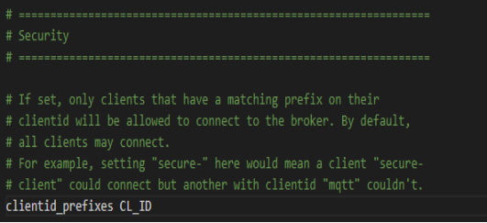

* To enable client authentication using credentials, you also need to set **allow_anonymous** parameter to false in mosquitto.conf file.

**allow_anonymous false**

* To create a password file, the mosquitto broker comes with mosquitto_passwd utility which creates a password file. To create the user name and password “**mosquitto_passwd -c passwordfile username**” the it ask for password and give.Make the password to be hash by this command  **“mosquitto_passwd -U passwordfile”** In the mosquitto config file give the path of our password file. Then start the mosquitto broker.

**password_file C:\Programfile\mosquitto\passwordfile**

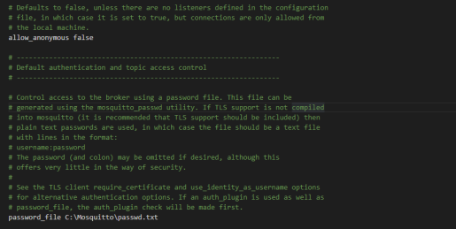

* Open the command prompt and give the command to start the broker.

**mosquitto -c mosquitto.conf -v**

* Now broker will start to run.
* Open one more command prompt in administration mode then try to establish the connection

**Mosquitto_sub -d -t topic -u username -P password**

OR

* From mqtt explorer also you can connect to the broker

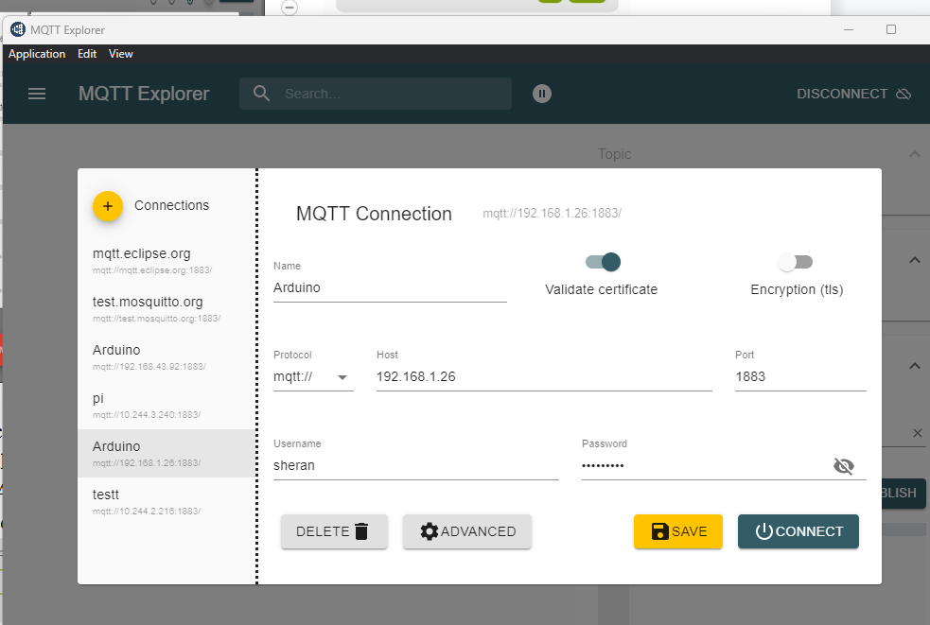

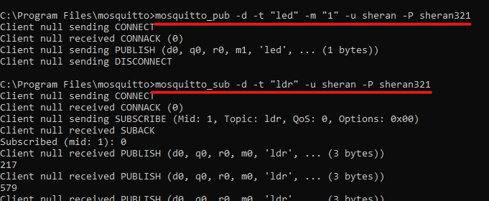

Mobile client to connect with broker.

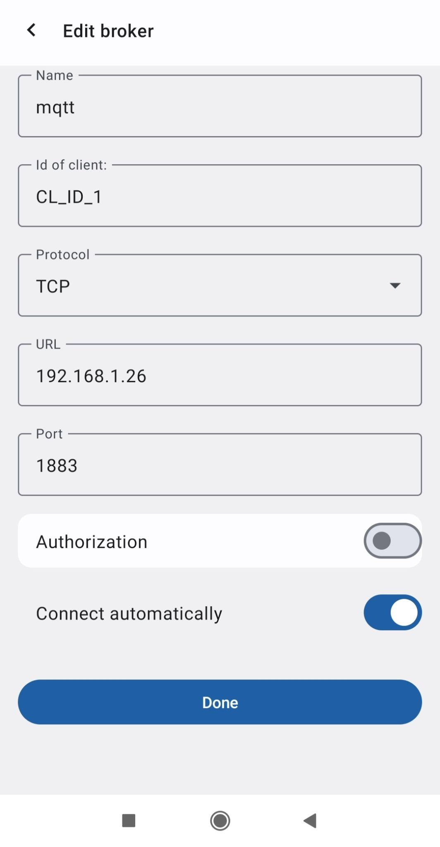

Steps to connect esp32 as client

* Open arduino ide and write code for the esp32. We need to install ESP32 dev module, mqtt pub-sub client library, choose the port number correctly.
* Provide the proper clientid , username and password to establish the connection inside the code.

You can see the connection details in the serial monitor.

**NOTE :- incase authentication error rc=5 occurring do this steps.**

For using 1883 port number go to windows defender firewall >advance setting > inbounded > new rules. Make enable the port number 1883.

